A Project Report

on

***HOME AUTOMATION USING ARDUINO & WI-FI***

*Submitted for the partial fulfillment of the requirement for the award of the Degree of*

***Bachelor Of Technology***

In

***Computer Science & Engineering***

by

**Sameer Dudeja (160102172)**

**Akul Aggarwal (160102175)**

**Mohit Shrivastava (160102185)**

Under the Guidance of

**Mrs. Madhu Sharma**

Assistant Professor

Computer Science & Engineering

DIT University, Dehradun



**DIT UNIVERSITY, DEHRADUN, INDIA**

April’201

A Project Report

on

***HOME AUTOMATION USING ARDUINO & WI-FI***

*Submitted for the partial fulfillment of the requirement for the award of the Degree of*

***Bachelor Of Technology***

In

***Computer Science & Engineering***

by

**Sameer Dudeja (160102172)**

**Akul Aggarwal (160102175)**

**Mohit Shrivastava (160102185)**

Under the Guidance of

**Mrs. Madhu Sharma**

Assistant Professor

Computer Science & Engineering

DIT University, Dehradun



**DIT UNIVERSITY, DEHRADUN, INDIA**

April’2019



**DECLARATION**

This is to certify that the Project entitled **“Home Automation using Arduino & Wi-fi”** in partial fulfillment of the requirement for the award of the **Degree of Bachelor of Technology** in **Computer Science & Engineering**, submitted to **DIT University, Dehradun, Uttarakhand, India,** is an authentic record of bona fide work carried out by us, under the guidance of **Mrs. Madhu Sharma.**

The matter embodied in this Project/Thesis/Dissertation has not been submitted for the award of any other degree or diploma to any University/Institution.

|  |  |  |
| --- | --- | --- |
| **Students Name & Signature:** |  | **Supervisor Name , Designation & Signature:** |
| Sameer Dudeja  Mohit Shrivastava  Akul Agarwal |  | Mrs. Madhu Sharma  Assistant Professor,  Computer Science & Engineering,  DIT University,Dehradun |
|  |  |  |
|  |  |  |
|  |  |  |
| **Dr. Vishal Bharti**  **Head of Department**  **Signature** |  |  |

***Date:29/04/2019***

***Place: Dehradun***

iii



**CERTIFICATE**

This is to certify that the Project entitled **“Home Automation using Arduino & Wi-fi”** in partial fulfillment of the requirement for the award of the **Degree Bachelor of Technology** in **Computer Science & Engineering** ,submitted to **DIT University, Dehradun, Uttarakhand, India,** is an authentic record of bona fide research work carried out by **Mr. Sameer Dudeja** (160102172) ,under my supervision/guidance.

**SignatureandNameof**

**Supervisor(s)/Guide**

**Mrs. Madhu Sharma**

Assistant Professor

Computer Science & Engineering

DIT University, Dehradun

***Date:29/04/2019***

***Place: Dehradun***

iv



**CERTIFICATE**

This is to certify that the Project entitled **“Home Automation using Arduino & Wi-fi”** in partial fulfillment of the requirement for the award of the **Degree Bachelor of Technology** in **Computer Science & Engineering** ,submitted to **DIT University, Dehradun, Uttarakhand, India,** is an authentic record of bona fide research work carried out by **Mr. Mohit Shrivastava** (160102185) ,under my supervision/guidance.

**Signature and Name of**

**Supervisor(s)/Guide**

**Mrs. Madhu Sharma**

Assistant Professor

Computer Science & Engineering

DIT University, Dehradun

***Date:29/04/2019***

***Place: Dehradun***

v



**CERTIFICATE**

This is to certify that the Project entitled **“Home Automation using Arduino & Wi-fi”** in partial fulfillment of the requirement for the award of the **Degree Bachelor of Technology** in **Computer Science & Engineering** ,submitted to **DIT University, Dehradun, Uttarakhand, India,** is an authentic record of bona fide research work carried out by **Mr. Akul Aggarwal** (160102175) ,under my supervision/guidance.

**Signature and Name of**

**Supervisor(s)/Guide**

**Mrs. Madhu Sharma**

Assistant Professor

Computer Science & Engineering

DIT University, Dehradun

***Date:29/04/2019***

***Place: Dehradun***

vi

**ACKNOWLEDGEMENT**

We take this opportunity to express our profound gratitude and deep regards to everyone who has helped us in completing this project.  We have taken efforts in this project. However, it would not have been possible without the kind support and help of many individuals and organizations and we would like to extend our sincere thanks to all of them.

We are highly indebted to Mrs. Madhu Sharma for her guidance and constant supervision as well as for providing necessary information regarding the project & also for her support in completing the project. We are wholeheartedly thankful to her for giving us her valuable time, attention and for providing us a systematic way for completing our project in time.

We must make special thanks to our H.O.D. Dr. Vishal Bharti and DIT University for giving us this opportunity and platform to show case or skills in our various fields of interests.

Lastly, we thank our parents and friends for their constant encouragement in developing the project and people who have willingly helped us out with their abilities.

vii

**ABSTRACT**

This project presents a design and prototype implementation of new home automation system that uses WiFi technology as a network infrastructure connecting its parts. The proposed system consists of two main components; the first part is the server (web server), which presents system core that manages, controls, and monitors users’ home.

Users and system administrator can locally (LAN) or remotely (internet) manage and control system code. Second part is hardware interface module, which provides appropriate interface to sensors and actuator of home automation system.

Unlike most of available home automation system in the market the proposed system is scalable that one server can manage many hardware interface modules 5 as long as it exists on WiFi network coverage. System supports a wide range of home automation devices like power management components, and security components.

The proposed system is better from the scalability and flexibility point of view than the commercially available home automation systems.

viii

**TABLE OF CONTENTS**

**Title Page No.**

DECLARATION.................................................................................iii

CERTIFICATE………...……………………………………………...iv-vi

ACKNOWLEDGEMENT…………………………………………….vii

ABSTRACT……………………………………………………..…....viii

TABLE OF CONTENTS……………………………………..……....ix-x

LIST OF FIGURES...........................................................................xi

ABBREVIATIONS…………………………………………………..

**CHAPTER 1INTRODUCTION**

1.1 Purpose ...................................................................................1

1.2 Objective .................................................................................2

1.3 Motivation……………………….……………………………..…3

1.4 Definition and Overview………………………………………….3-4

**CHAPTER 2 OVERALL DESCRIPTION**

2.1 Project Perspective ..................................................................5-6

2.2 Project Functions…….………..................................................6-7

2.3 Diagrams…………………………………………………………..8-9

2.3.1 E-R Diagram ……………………………………………….8

2.3.2 Use Case .…………………………………………………...9

2.4 Constraints and Assumptions…................................................9-10

**CHAPTER3 EXTERNAL INTERFACE REQUIREMENTS**

3.1 User Interfaces……………………………………………………..11

3.2 Hardware Interfaces…………………………………………….....11

3.3 Software Interfaces………………………………………………....11-12

3.4 Communications Interfaces…………………………………….….12

**CHAPTER4SYSTEM FEATURES**

4.1 Code Snippet………………………………………………………......13

x

4.2 Output………………………………………………………………….13

4.3Node Deployment……………………………………………………...14

4.4 MATLAB……………………………………………………..……….14

**CHAPTER 5OTHER NONFUNCTIONAL REQUIREMENTS**

5.1 Performance Requirements…………………………………………….15

5.2 Safety Requirement………………………………………………….....15-16

5.3 Security Requirements………………………………………………....16

5.4 Software Quality Attribute…………………………………………......16

**CHAPTER 6 CONCLUSIONANDFUTUREWORK**

6.1 Conclusions ........................................................................................17

6.2 Scope for Future Work .......................................................................17

REFERENCES …………………………………………………………...18

x

**LIST OF FIGURES**

**Figure No. Title Page No**.

2.1 Circuit Diagram…………………………………………………….…..8

2.1.1 Gas Module Circuit Diagram…………………………………………..8

2.1.2 Temperature and Water Overflow Sensor Module Circuit ……………8

2.1.3 Camera Module Circuit Diagram………………………………………9

2.2 Flow Chart of Proposed System …………………………………...….9

4.1 Code Snippet……………………………………………………….....13

4.2 Output…………………………………………………………………13

4.3 System requirement for MATLAB…………………………………...14

xi

**ABBREVIATIONS**

1. GSM- Global System for Mobile Communications
2. ZIGBEE- It is an IEEE based specification for a suite of high level communication protocols used to create personal area networks with small, low-power digital radios, such as home automation and other low-power low-bandwidth needs, designed for small scale projects.
3. RFID- Radio-Frequency Identification, uses electromagnetic fields to automatically identify and track tags attached to objects.

**CHAPTER 1**

**INTRODUCTION**

**1.1 PURPOSE OF THE PROJECT**

**Home Automation** is a term used to describe the working together of all household amenities and appliances. The household activities are automated by the development of special appliances such as water heaters to reduce the time taken to boil water for bathing and automatic washing machines to reduce manual labour of washing clothes. In developed countries, homes are wired for electrical power, doorbell, TV outlets, and telephones. The different application includes when a person enters the room, the light turns on. In advanced technology, the room can sense the presence of the person and who the person is.

In case of a home theatre, the home automation system can avoid distraction and lock the audio and video components and can also make an announcement. The home automation system can also dial up the house owner on their mobile phone to alert them or call any alarm monitoring company.

It is essential that the different controllable appliances be interconnected and communicate with each other. The basic aim of Home automation is to control or monitor signals from different appliances, or basic services. A smart phone or web browser can be used to control or monitor the home automation system.

**1.2 OBJECTIVE**

The improper and inefficient use of the resources given to us is just a mistake considering that the sources are fleeting away. Improper use of electricity, water etc. can and will cost us, so it’s better to preserve.

The main objective of this project is to mark a simple step towards a better future by putting better use of the resources given to us.Considering the day of the week, time of the day and other such factors it can also set appropriate lighting, temperature levels, television channels or music levels. In the case of a smoke detector when fire or smoke is detected, the lights in the entire house begin to blink to alert the resident to the probable fire.

With this project we wish to make modules that can transmit data to the user using various sensors over the internet using Wi-Fi. The user will be able to access the data on any browser connected on the same Home network.

**1.3 MOTIVATION**

The motivation to choose Home Automation is the upper hand it provides in making this project. The motivation for doing this project is primarily an interest in undertaking a challenging project in an interesting area of research. The opportunity to learn about a new area of IOT which is not covered in lectures is appealing. We have chosen this project since we were totally able to relate to the topic and were fascinated by idea of controlling various items remotely using an app/web app/or any kind of remote able to give instructions. This irregular behavior of students not only affect tem but other students and teachers as well. As this has become a major concern of modern time educational institutions it has become important to get know of the factors causing such irregularities among the students which may create negative impact. The major factor that motivated us to do this project is the possibilities it unfolds.

The fact is indisputable that, having the above introductory paragraph as a schedule, in reality, will certainly make the future homes fascinating and maybe this is just the infrastructure for a fully automated home using AI. Yet, this project needs major upgrades to be able to perform that level of computation. This project, therefore, is a small initiative by us to take one small step towards the development of fully Automated Home.

**1.4 DEFINITION AND OVERVIEW**

There are many methods currently in use to automate Homes and below are their drawbacks:

1**. Home Automation using Bluetooth:** This method usesa Bluetooth module connected to a micro-controller like Arduino or Raspberry Pi etc. for computation and transmitting of data. The main drawback would be the Range on which Bluetooth works and the limited no. of modules we can connect to the system.

2. **Home Automation using GSM:** This method uses a GSM module which would work on a Sim card and send the data using the same protocols by which we make a phone call or send a text message or access the internet. Although based on a network that uses satellites, this method is not very cost efficient, and it majorly depends on the Network Strength and may malfunction over a network congestion scenario.

3. **Home Automation using Wi-fi:** This method uses a Wi-Fi module connected to a micro – controller to send data to different data receivers over the internet. The main drawback of this method would be the range which can be increased with increased cost of the system.

**CHAPTER 2**

**OVERALL DESCRIPTION**

**2.1 PROJECT PERSPECTIVE**

The main problem better use of resources , like in saving electricity or water and/or maintaining a livable and hospitable home environment. The solution to this problem must be a complete system, as it must be implemented throughout the world for the solution to be even considered. IoT provides a perfect platform for a solution of this archetype. With all this in mind, we decided to implement a feasible and efficient IoT based solution using **Arduino** for the problem at hand. There are total 4 modules in the Home Automation System we are working on, each having their different aims and functioning.

Total no. of modules in our system are as follows:

1. Temperature and Water control Module: This module contains a DH11 sensor and a Water Overflow sensor connected to a Node MCU which is making a web server and displaying the readings on a specific IP address which in this case is 192.168.43.117 .The circuit diagram is indicated in figure 2.1.1 and the output is indicated in fig. 2.5.1 .The code snippet

In this phase we have emphasised and worked on the simulation of sensors that we are going to use in hardware programming of our project.

.Instead of using ZIGBEE,RFID, we are making this setup IOT based to overcome the consequences of the above. This would improve the accuracy of the records, approve proper paid days and leave days of the staff and this shall all be monitored by a superior authority because it will remove all the hassles of the staff rushing for their attendance consideration on register and then the difficulties in payment making of the staff due to improper attendance consideration.

This project aims to bring out an easy way to mark attendance of students in efficient manner with the use IOT based sensors which will work in following way:

SIMULATION

1-Initialization of sensors.

2-Deployment of sensors.

FACE DETECTION

1-Image capture:

2-Uploading Process:

3-Face Recognition:

4-Database Development:

**2.2 PROJECT FUNCTION**

The Project functions in a following way:

Initialization:

1-Initial energy of nodes- here each node is provided an energy of 1J.

2- Deployment- done in (x,y,z) coordinates. Deployment can be done in two ways:

i)Random-when the sensors are placed in a random order anywhere in the space is referred to as random deployment.

ii)Grid-when the sensors are placed in a particular manner or order in the space is referred to as grid deployment.

3- Number of nodes –Nodes represent total number of sensors used in a building.

4- Transmission range ($T_{x}$ R)- It is the maximum distance up to which the sensor can transmit the data. It may vary from node to node.

5- Path Loss Exponent-It is the reduction in energy density of a node as it transmits data through space. Path loss may occur dur to many affects such as free space loss, refraction, diffraction.

It can be written as: $\boxed{E_{tx} (m,d)∝md^{n}}$

here m=number of bits, d= distance between nodes, n=path loss exponent.

Usually, 2 $≤n≤$ 6

Where,

2 is used for free space and 6 for any wall or other medium in between

Here we are taking n=3.

6- Neighbour Density-it defines the number of nodes present in the neighbourhood of the source node.

7- Lifetime- it is defined as the time till the first node dies out (from the point of deployment)It is given as L=t’-t

Where,t’=final time and t=initial time.

After the simulation of sensors, we will get to know about how the sensors to be placed in each classroom.

Now , the **camera modules** are to be placed in each class room such that it captures snapshots at a certain period of time

Following tasks will be performed:

1-Image capture:It starts taking images in a burst. It uploads each picture to the cloud for analysis.

2-Uploading Process:on the cloud requires the face in the frame of the picture to be assigned with a face ID.

3-Face Recognition:Face Identification is done using recognition techniques developed by Microsoft and embedded in its API.

4-Database Development:A table is developed on the cloud. Once a person is identified, it is necessary to check if the person is already marked present for the day or not.

In the second phase we are using the camera in classroom whose storage is cloud.

Here we are taking a frame from the continuous set of frame.

We already have the database of Students which contains images and registration no of each student.

**2.3 DIAGRAMS**

**2.3.1 Circuit DIAGRAM**

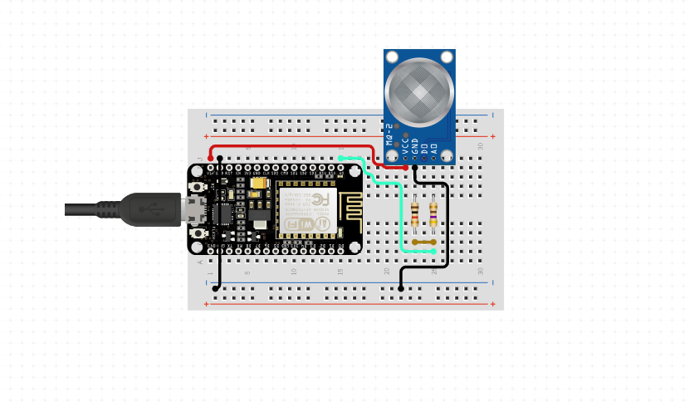

*FIG 2.1.1: Gas module Circuit diagram*

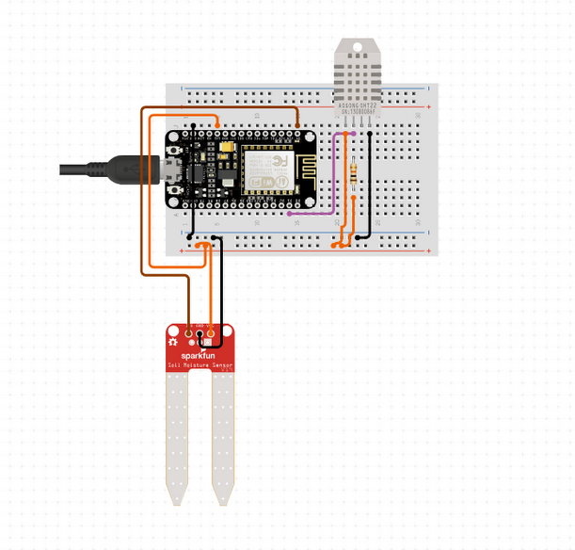

*Fig 2.1.2 Temperature and Water Overflow Circuit diagram*

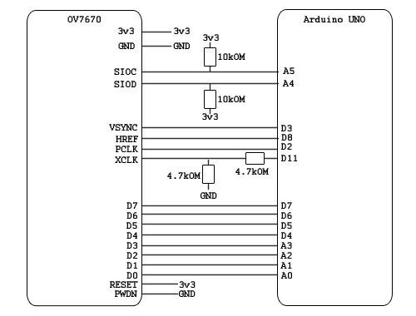

*Fig 2.1.3, Camera Module Diagram*

**2.3.1 USE CASE**

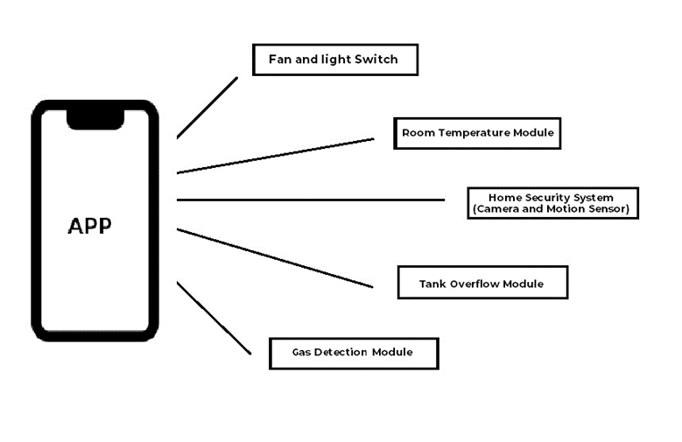

*FIG 2.2: flow chart of proposed model*

**2.4 CONSTRAINTS AND ASSUMPTIONS**

Assumption are as follows:

Number of nodes –Nodes represent total number of sensors used in a building.

Transmission range ($T_{x}$ R)- It is the maximum distance up to which the sensor can transmit the data. It may vary from node to node.

Path Loss Exponent-It is the reduction in energy density of a node as it transmits data through space. Path loss may occur due to many affects such as free space loss, refraction, diffraction.It can be written as: $\boxed{E_{tx} (m,d)∝md^{n}}$

here m=number of bits, d= distance between nodes, n=path loss exponent.

Usually, 2 $≤n≤$ 6. Here we are taking n=3.

Neighbour Density-it defines the number of nodes present in the neighbourhood of the source node.

Lifetime- it is defined as the time till the first node dies out (from the point of deployment).It is given as L=t’-t

Where,t’=final time and t=initial time.

# CHAPTER 3

# EXTERNAL INTERFACE REQUIREMENTS

# 3.1 USER INTERFACES

In user interface we define user, task, environment analysis and describe the external and internal components and the architecture of user interface with some rough pictorial views of the user interface and its components.

Here we are going to make a software which will help teachers and students by efficiently taking their attendance rather than the conventional methods of marking attendance. This interface will be easy to use and student’s attendance will be uploaded directly into their attendance portals.

# 3.2 HARDWARE INTERFACES

For implanting the current code (i.e. of phase 1), we are doing simulation to find which protocol we are going to use, for this MATLAB is being used and we need the following hardware interfaces (windows specific) for the same:

* Operating Systems: Windows 10, Windows Service Pack 1, Windows Server 2019, Windows Server 2016.
* Processors: Any Intel or AMD x86-64 processor(minimum), Any Intel or AMD x86-64 processor with four logical cores and AVX2 instruction set support(recommended)
* Disk: 2.9 GB of HDD space for MATLAB only, 5-8 GB for a typical installation(minimum)
* RAM: 4GB (minimum), 6GB(Recommended)
* Graphics: No specific graphics card is required.

# 3.3 SOFTWARE INTERFACES

This application is using MATLAB for simulating the different protocols we will be using to send the details of attendance from classrooms in various buildings of the campus to the cloud server. Then based on the real-time results of the working of these protocols we’ll be using the one which is best suitable for application.

MATLB is a multi-paradigm numerical computing environment; it is intended primarily for numerical computing. It also has tightly integrated graph-plotting features. MATLAB can call functions and subroutines written in the programming languages C or Fortran.

# 3.4 COMMUNICATION INTERFACES

# The communication interface used here is attendance monitoring using face recognition through IOT and for deploying this we are using various sensors installed in buildings. Then the data will be sent to cloud server through various protocols.

**CHAPTER 4**

**SYSTEM FEATURES**

**4.1 CODE SNIPPET**

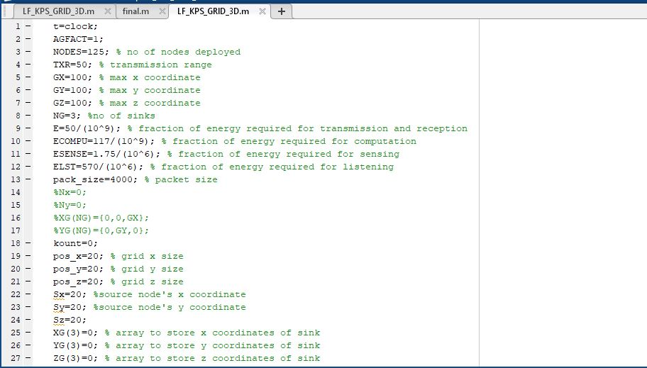

*FIG 4.1:Code snippet*

**4.2 OUTPUT**

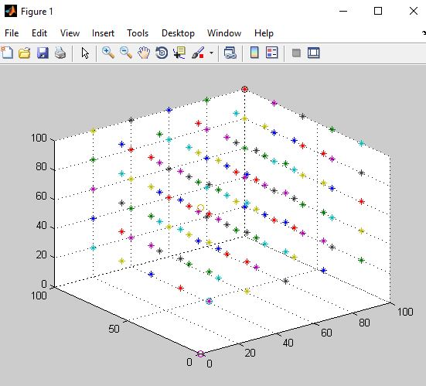

*FIG 4.2: Output*

**4.3 NODE DEPLOYMENT**

Sensors nodes generates huge amount ofsimilar packets, data aggregation is used to reduce the transmission of similar packets. Data aggregation is combination of information from different sensor nodes by applying functions like suppression, average, maximum. The routing protocol incorporates this data aggregation technique to reduce data redundancy and achieve energy efficiency.

In WSN motes are deployed according tothe demand of the application. Thus affects the productivity of the routing protocol. The nodes are deployed in uniform way or randomized way. In uniform way, the nodes are placed manually at fixed spot and routing paths are predetermined. In randomized way, the nodes are scattered randomly. This causes several issues such as optimal clustering, coverage etc. The position of the sink node or cluster head is an important factor in terms of energy efficiency. Data transfer through these one node to another in wireless network in face recognition in a randomized way.

**4.4 MATLAB**

This section describes hardware and software requirements for running the MATLAB software.

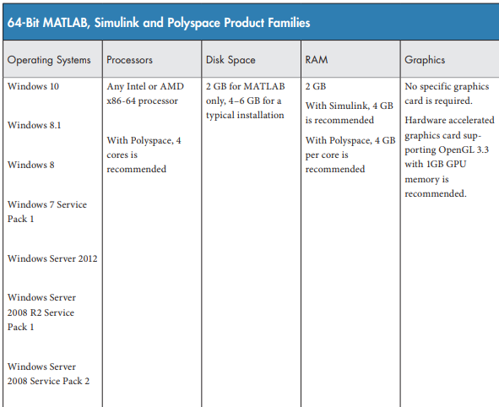

*FIG 4.3: System Requirements For MATLAB*.

**CHAPTER 5**

**OTHER NONFUNCTIONAL REQUIREMENTS**

**5.1 PERFORMANCE REQUIREMENTS**

We use Face Recognition Techniques to recognize students. The knowledge of presence of students may help in more regular sessions. This would definitely give better results not only in terms of marks but also in terms of knowledge. If students learn regularly then only can they be effective to themselves. We want to convey that when sessions are held regularly, they are for our own good and our project would be a working model towards our motive.

This project deals with marking a student present or absent on the basis of his identification from the pre-loaded dataset. If the attendance is marked by a trained machine, which consist of a particular dataset, it becomes quite a difficult task to escape from it. The student has to appear in front of it to mark himself present for a particular session. This project aims for a collected data set, which would identify faces using Face Recognition Techniques and generating attendance on an excel sheet simultaneously. The output thus generated gives us an attendance sheet with students marked present or absent. This output can then be used by the respective authority to take corrective measures to improve such irregularities.

**5.2 SAFETY REQUIREMENTS**

In today’s life, an increased absence of students from class is quite a common scene. This leads to fatal consequences for a student as well as a teacher such as-

* Incomplete syllabus
* Irregular sessions
* Unfruitful sessions
* Waste of time of those who are interested to gain knowledge

Our project titled –**Face Recognition on e-attendance**, helps in improving this irregular strength of students in class.

Several factors leads to development of such irregular behavior. This has become an unavoidable tendency in most classes and sessions. This when prolonged, affects not only the concern’s marks but also his related mates and teachers. Therefore, it is essential to have a mark of students and not let them take advantages of the loopholes provided unintentionally.

**5.3 SECURITY REQUIREMENTS**

Face recognition security is about using a human face as a security code or key. Face recognition security works with faceprints and identify eight nodal points on the face of an individual. Face recognition security system allows authenticated user to mark the attendance in the excel sheet. Using a human face as a key and match with the dataset created by the user by capturing his image from different angles and if the face matches with the dataset then mark the attendance in a excel sheet.

**5.4 SOFTWARE QUALITY ATTRIBUTES**

Our webcam is used as the camera source. So, it captures images, creates dataset and identifies the faces. Students are asked to sit in front of the camera for a particular time and give different face expressions and angles so as to obtain a data set with vivid images. The lighting is kept such that it is neither too dim nor too bright. The data set created contains gray images. The webcam records a video out of which fixed number of images are extracted to create an image data set. The collected data set is then trained. This trained data set is then further processed by a recognizer so that our model recognizes each face. As soon as the recognizer starts working it simultaneously starts marking attendance in an excel sheet. An excel attendance sheet is thus obtained as the output.

# CHAPTER 6

# CONCLUSION AND FUTURE WORK

# 6.1 CONCLUSIONS

# A system for automating the process of attendance has been proposed using IOT technology and face recognition (image processing).The proposed system can prove to be utilitarian for not only academic institutions but also in other professional environments.

# 6.2 SCOPE FOR FUTURE WORK

The attendance data collected could be used later to find various statistical relation with respect to the student performance. The project can be extended in other interesting ways, such as implementation of system for security access, dynamic face detection in public places.

The whole system can be improved by increasing the efficiency of the face detection algorithms used. It can further be improved to automatically calculate the attendance percentage of the students and intimate the teachers and parents if a student’s attendance is below a certain percentage.

**REFRENCES**

1. <http://www.ijarcce.com/upload/2016/si/ICRITCSA-16/IJARCCE-ICRITCSA%203.pdf>
2. Mahesh Sutaret al, “Smart Attendance System using RFID in IOT”, International Journal of Advanced Research in Computer Engineering & Technology (IJARCET) Volume 5, Issue 4, April 2016
3. M. NewlinRaajkumar et al, “Efficient and portable fingerprint based attendance system using geo sensor”, International Journal of Advanced Research in Biology Engineering Science and Technology (IJARBEST), Vol. 2, Special Issue 10, March 2016
4. Ankita Agrawal et al, “Online Attendance Management System Using RFID with Object Counter, International Journal of Information and Computation Technology.ISSN 0974-2239 Volume 3, Number 3 (2013), pp. 131-138
5. Riya Lodhaa et al, “Bluetooth Smart based Attendance Management System”, International Conference on Advanced Computing Technologies and Applications (ICACTA-2015) 22 [6] Josphineleela.R and M.Ramakrishnan, “An Efficient Automatic Attendance System Using Fingerprint Reconstruction Technique”, (IJCSIS) International Journal of Computer Science and Information Security, Vol. 10, No. 3, March 2012

“Internet of Things - A Hands-on-Approach”, 1st Edition by Vijay Madisetti and ArshdeepBahga.